

Drake Primary School - Climate Action Plan
Where a World of Opportunity Awaits

OUR VISION
Our school and curriculum empower pupils to be advocates and agents of change for a more sustainable world.
OUR MISSION
- We are imaginative: we dream, read and travel.
- We are inquisitive: we listen, question and challenge.
- We are disciplined: we improve, hone and practise.
- We are collaborative: we share, connect and support.
- We are persistent: we dare, struggle and stick at it.
OUR AIMS
- Prioritise mental health and wellbeing
- Help everyone find joy in learning, feel safe to make mistakes and know when they are successful
- Have a curriculum that represents local, national and global diversity
- Recognise everyone’s role in the future of the world and its climate
- Make a place where difference and diversity are valued
- Link learning to the world of work
- Make pupil, family and staff voices integral to our planning
- Nurture creativity through the arts
- Develop a culture of reading for pleasure
- Ensure our pupils play safely, demonstrate our school values and build resilient friendships
Climate Action Plan – Last updated: 21/1/25
Sustainability at Drake: https://www.drake.norfolk.sch.uk/sustainability/
Climate Action Plan Areas:
- Adaptation and resilience: taking actions to reduce the risk of flooding and overheating.
- Biodiversity: getting to know our outdoor space and improving the school grounds for people and nature.
- Climate education and green careers: ensuring the education we provide gives knowledge-rich and comprehensive teaching about climate change, and that our teaching staff feel supported to offer this.
- Decarbonisation: calculating and taking actions to reduce our carbon emissions, such as becoming more energy efficient.
Adaptation and Resilience

Our Vision - How can we adapt our buildings and systems to prepare for the effects of climate change?

- We will understand how the changing climate is affecting Thetford and Drake school buildings.
- We will prepare for the effects of climate change in our classrooms and in school buildings.
- We will risk assess extreme climate events at Drake (ie: flash flooding and overheating), to ensure emergency preparedness.
Prompt Questions:
- Has the education setting undertaken an assessment of climate and weather risks?
- Has the education setting experienced the effects of extreme weather in the past e.g. high temperatures in summer, flooding of buildings or grounds?
- What aspects of the education settings life has been or could be affected by these hazards? What damages were incurred?
- Who are the important people in the setting with responsibilities for preparing for and responding to these events?
- Does the setting have any vulnerable staff or students that could be at greater risk?
- Is there any important infrastructure that the setting needs to ensure remains operational, or is high cost e.g. IT equipment, boiler, laboratory or other specialist equipment?
- Does the education setting have any existing plans for action in the event of a heat wave or flood?
- Does the setting know where they can find out what their local climate might look like in the future and how these extreme events might change?
Action  (highlighted = completed) | Link to  Improvement Plan / School Policies | Responsibility and Key Stakeholders | Timescale | Information and/or resources required | Cost | Progress  (Update at regular review points)
Overheating plan: Plan for a heatwave: Consider what adjustments will be made in hot weather.  Write a heatwave policy / risk assessment  Consider adding shaded structures in play areas. Undertake shade mapping NENP activity. | Leadership and management: Governors or trustees ensure that the school fulfils its statutory duties, for example the health, safety and wellbeing of all pupils with regards to extreme weather events.  Recognise everyone’s role in the future of the world and its climate. | SF  DW  SC (Site manager)  Mallards (PTA)  HR and MB (Site staff) | Start date: May 2025  Review Date: Jul 2025 | Useful links:  https://educationhub.blog.gov.uk/2023/07/12/hot-weather-and-heatwaves-guidance-for-schools-and-other-education-settings/  https://www.educationnaturepark.org.uk/resource/shade-mapping | Staff time | SC - shade - created a capital project for this.  Draft adverse weather risk assessment
Flood plan: Plan for flash flooding  We have learnt that the school is at high risk from surface water flooding (‘flash flooding’). Flash flooding happens when rainwater cannot drain away through normal drainage systems.  Increase awareness of flood risks both globally and in the local area due to climate change.  Increased awareness of what parts of Thetford are at risk from river floods. |  | SF  DW  SC (Site manager) | Start date: May 2025  Review Date: Jul 2025 | Useful links: https://www.gov.uk/prepare-for-flooding  https://practicalaction.org/schools/beat-the-flood/  https://www.anglianwater.co.uk/your-local-area/education/schools/primary-resources/ | Staff time | SC - is meeting Abbie from NCC as we have been identified as at risk.
Water sustainability: Raise awareness around water consumption.  Install a rainwater planter in the red playground to catch runoff from the KS2 roof that would otherwise go into the drain. |  | DW  Gardening Club  Mia Witham | Start date: Sept 2023  Review Date: Sept 2024 | Useful links: https://www.groundwork.org.uk/how-to-create-a-rain-garden-planter/ | Staff time | Rainwater planter installed in Summer 2024 in red playground
Policy: Meet with UEA Climate Ambassador Kit Rackley to discuss CCE implementation into safeguarding policy. |  | DW  SF  KF  Kit Rackley | Start date: Oct 2024  Review Date: Feb 2025 | Useful links:  https://tyndall.ac.uk/people/kit-marie-rackley/  https://www.stem.org.uk/stem-ambassadors | Staff time | Meeting held with KMR on 3.12.24
Policy: Include eco-anxiety and emergency preparedness for extreme weather events in the safeguarding policy. |  | DW  SF  KF  Kit Rackley  SLT | Start date: Nov 2024  Review Date: Mar 2025 | Useful links: | Staff time | 10/1/25 email sent with paragraph to be included on safeguarding policy referring to climate action plan.

Biodiversity
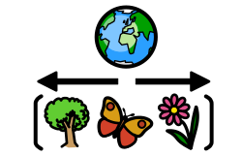
Our Vision- How can we enhance biodiversity, improve air quality and increase access to, and connection with, nature?

- We will map and monitor the biodiversity across the Drake site.
- We will increase biodiversity and habitats on the Drake school site.
- We will make more frequent use of our outdoor areas.
Prompt Questions:
- Has the education setting mapped and recorded biodiversity on their campus?
- Could the settings estate be managed differently, to provide habitats that serve to enhance local biodiversity?
- Does the estates team need CPD and/or help to provide habitats that enhance local biodiversity?
- Do pupils have opportunities to learn in and about nature? Could this be enhanced on the education settings campus or using facilities elsewhere in the local community?
Action  (highlighted = completed) | Link to  Improvement Plan | Responsibility and Key Stakeholders | Timescale | Information and/or resources required | Cost | Progress  (Update at regular review points)
Biodiversity: Classes to undertake a BioBlitz around school in each term- can use National Education Nature Park’s ‘Hidden Nature Challenge’ to gather and track biodiversity data.  Each year has an area of the school grounds to study throughout the year. As part of the BioBlitz , the class finds and identifies as many species as possible in a specific area. | Behaviour and attitudes: Pupils behave with consistently high levels of respect for others. They play a highly positive role in creating a school environment in which commonalities are identified and celebrated, difference is valued and nurtured. Examples of this can be found is our whole-school action on protecting nature.  Empower pupils to be advocates and agents of change for a more sustainable world. | Class teachers  DW  SF  Jenna Gilmour (NENP) | Start date: Nov 2024  Review Date: Monitor each term | Useful links: https://www.drake.norfolk.sch.uk/bioblitz/ | Staff time | Autumn term BioBlitz complete by majority of year groups  Hidden Nature Challenge completed by Y3 on 10.12.24 with Jenna Gilmour  BioBlitz completed in BSW Mar 2025
Biodiversity: Complete wetland area which will create new ecosystems, habitats etc. |  | Eco Council  SF  DW | Start date: Jul 2024  Review Date: Maintenance ongoing | Useful links: | Staff time  Spirax Grant £20 000 to create wetland area  Pond dipping equipment funded by TEFT grant £5000 grant | Wetland area complete in Sept 2024
Biodiversity: Create a wildlife corridor along the edge of the school field from the wetland area to Sir Frederick’s Wood. |  | SF  DW  Gardening Club | Start date: Summer 2025  Review Date: Autumn 2025 | Useful links: https://www.woodlandtrust.org.uk/plant-trees/schools-and-communities/ | Staff time | Trees being delivered in March 2025. Volcanic UK coming in to help plant these for their community day.
Biodiversity: Develop allotment area- raised beds  Raise awareness of food seasonality and grow food.  Enter School gardening competition at Royal Norfolk Show (Literary Garden based on ‘The Secret Sky Garden’) |  | Gardening Club  DW  HR  After school club | Start date: Autumn 2024  Review Date: Ongoing | Useful links: https://schoolgardening.rhs.org.uk/home | Staff time | Gardening club prepared the raised beds in Autumn term, ready for planting in Spring 2025  Application in for RNS garden
Biodiversity: Register for National Education Nature Park.  Undertake biodiversity mapping of habitats in the school site. |  | Eco Council  SF  DW  Jenna Gilmour (NENP) | Start date:  Review Date: | Useful links: https://www.educationnaturepark.org.uk/ | Staff time | Registered in Oct 2024  Jenna Gilmour visited Drake for Biodiversity mapping on 28.11.24.  Biodiversity mapping completed with Y3s on 10.12.24
Biodiversity: Involve children in maintaining outdoor areas. Create signs to increase awareness of wild areas / pollinators / plant identification charts / insect identification charts. |  | DW  Gardening Club  HR | Start date: Autumn 2025  Review Date:  Autumn 2025 | Useful links: https://www.drake.norfolk.sch.uk/gardening-club/ | Staff time | Signs completed by gardening club in raised bed area in Autumn 2024
Cleaning products: Audit the cleaning products to find out which products are eco-friendly.  Replace cleaning products with eco-friendly versions if needed.  Establish a maintenance plan to reduce pesticide use and increase no mowed areas. |  | NOC  SC  Cleaners & Site staff | Start date: Spring 2025  Review Date:  Summer 2025 | Useful links: | Staff time | SC - COSHH - most of the products are eco friendly and not hazardous to the environment.

Climate Education, Green Skills and Careers

Our Vision - How can we prepare students for a world impacted by climate change through education and practice?

- We will embed climate change into our curriculum, initially focusing on science, geography, D&T and PSHE.
- We will offer CPD to staff so they feel confident teaching and talking about climate change.
Prompt Questions:
- In what parts of the education settings curriculum do pupils learn about nature, climate change and the importance of sustainability? Could this be broadened and developed? How could it be integrated across all subjects and educational stages?
- How confident are teaching staff in delivering climate change and sustainability material? Do they need CPD? Do they have access to high quality resources?
- Do pupils have opportunities to learn in the natural environment? How is this part of their curricula or extra-curricular programme?
- Are pupils made aware of the likely future career opportunities which exist in the green economy? Do staff have good training about these opportunities?
- What are the skills that pupils will need to be able to develop to access these careers? How can these skills be embedded across the educational offer?
Action  (highlighted = completed) | Link to  Improvement Plan | Responsibility and Key Stakeholders | Timescale | Information and/or resources required | Cost | Progress  (Update at regular review points)
Staff CPD: Training for sustainability leads  Climate Adapted Pathways in Education (CAPE) CPD course - Climate Wise Schools Expert School leader programme | Quality of Education: The school’s curriculum intent and implementation takes into account the changing world we are preparing our students for and as such, sustainability is embedded securely and consistently across the school.  Empower pupils to be advocates and agents of change for a more sustainable world. | DW  SF  KF | Start date: Jul 2024  Review Date: May 2025 | Useful links: https://www.capealliance.org.uk/ | Staff time  CAPE Course = £200 per staff member | Visit to Caister Primary on 10.10.24  In person climate literacy certification course 17.10.24  CAPE Course (Jul 2024 - May 2025)
Staff CPD: Training for staff  Green Schools Project: Pilot study with Eco Council running Autumn 24 - Summer 25.  Use Green Schools project resources in one year group (Y4) in summer term and then extend to the whole school in the following year.  Climate 180 Project: CPD for staff on climate change |  | DW  SF  Eco Council  Y4 teachers  Formation of climate working group (SF, DW, AA, ED, VL) | Start date: Oct 2024  Review Date: Summer 2025 | Useful links: https://www.greenschoolsproject.org.uk/  https://ltl.org.uk/projects/climate-school-180/ | Staff time  Green School Project= Funded place  Climate 180 = Funded place | Started Green Schools project on  Zero carbon schools training on 14.11.24  Climate 180 – accepted onto programme on 13.11. 24  Climate 180 training on 2.7.25  Climate 180 Grounds audit on 2.7.25  Climate 180 ‘Thinkific training’ programme
Staff CPD: Staff CPD on sustainability and climate change. |  | DW  SF | Start date: Summer 2025  Review Date: Autumn 2025 | Useful links: Webinar: Embedding Sustainability into the Primary Curriculum https://www.youtube.com/watch?v=CxovBafeRvk&t=323s | Staff time | Survey on 3.12.24 to collect staff voice on climate change.
Curriculum: Audit the current sustainability content in the curriculum, looking for links where climate education can be included.  Embed climate change and sustainability into our curriculum (across all subjects). Focused initially on science, geography and PSHE curriculum (eco-anxiety). |  | SLT  DW  SF  KF  Subject leads | Start date: Jun 2025  Review Date: Ongoing | Useful links: | Staff time | Links to science: Year 6- Environment unit in science ‘Looking after our environment’ (Developing experts)  Year 4- Environment unit - Living things and their habitats (Autumn term 2025)  Assemblies - linking Lyfta in
Curriculum: Link learning to the outdoor areas.  Provide more outdoor learning opportunities in the curriculum.  Encourage teachers to utilise outdoor spaces across the curriculum |  | DW  SF | Start date: Oct 2024  Review Date: Sept 2025 | Useful links: https://www.educationnaturepark.org.uk/ | Staff time | Staff CPD on 10.12.24 with Jenna Gilmour (NENP)
Green skills: Eco Schools- Apply for Eco Schools Green Flag Award in June 2025.  - Environmental Review  - Action Plan  - Curriculum links  - informing and involving  - Monitoring and evaluation  - Eco code |  | Eco Council  SF  DW | Start date: Sept 2024  Review Date: Jul 2025 | Useful links: https://www.eco-schools.org.uk/ | Staff time  Cost of application £200 | SF & DW signed up for Eco Schools Portal 24-25  Eco School training on:  Session 1: Thu 7 Nov 2024  Session 2: Wed 15 Jan 2025  Session 3: Wed 30 Apr 2025  Environmental review complete 18.10.2024  Eco Council assembly on climate change 22.11.24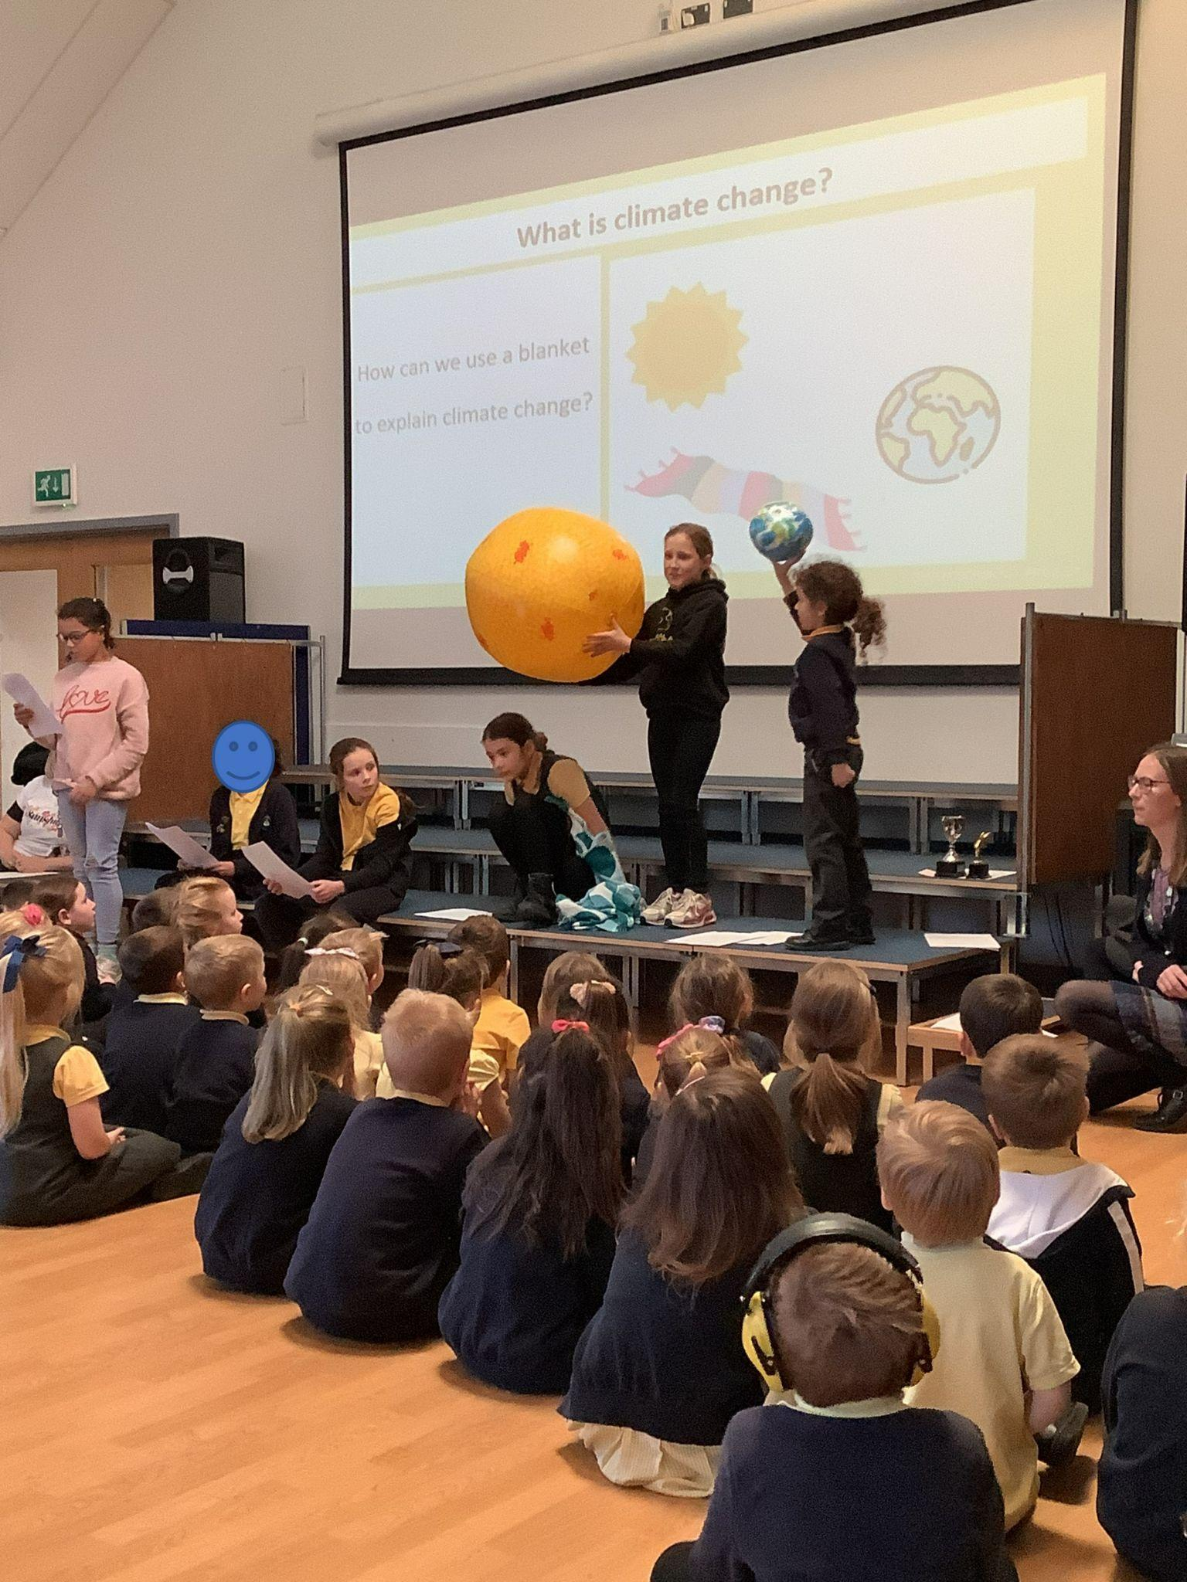  Environmental review complete Aut 2024  Eco Code for School completed Jan 2025  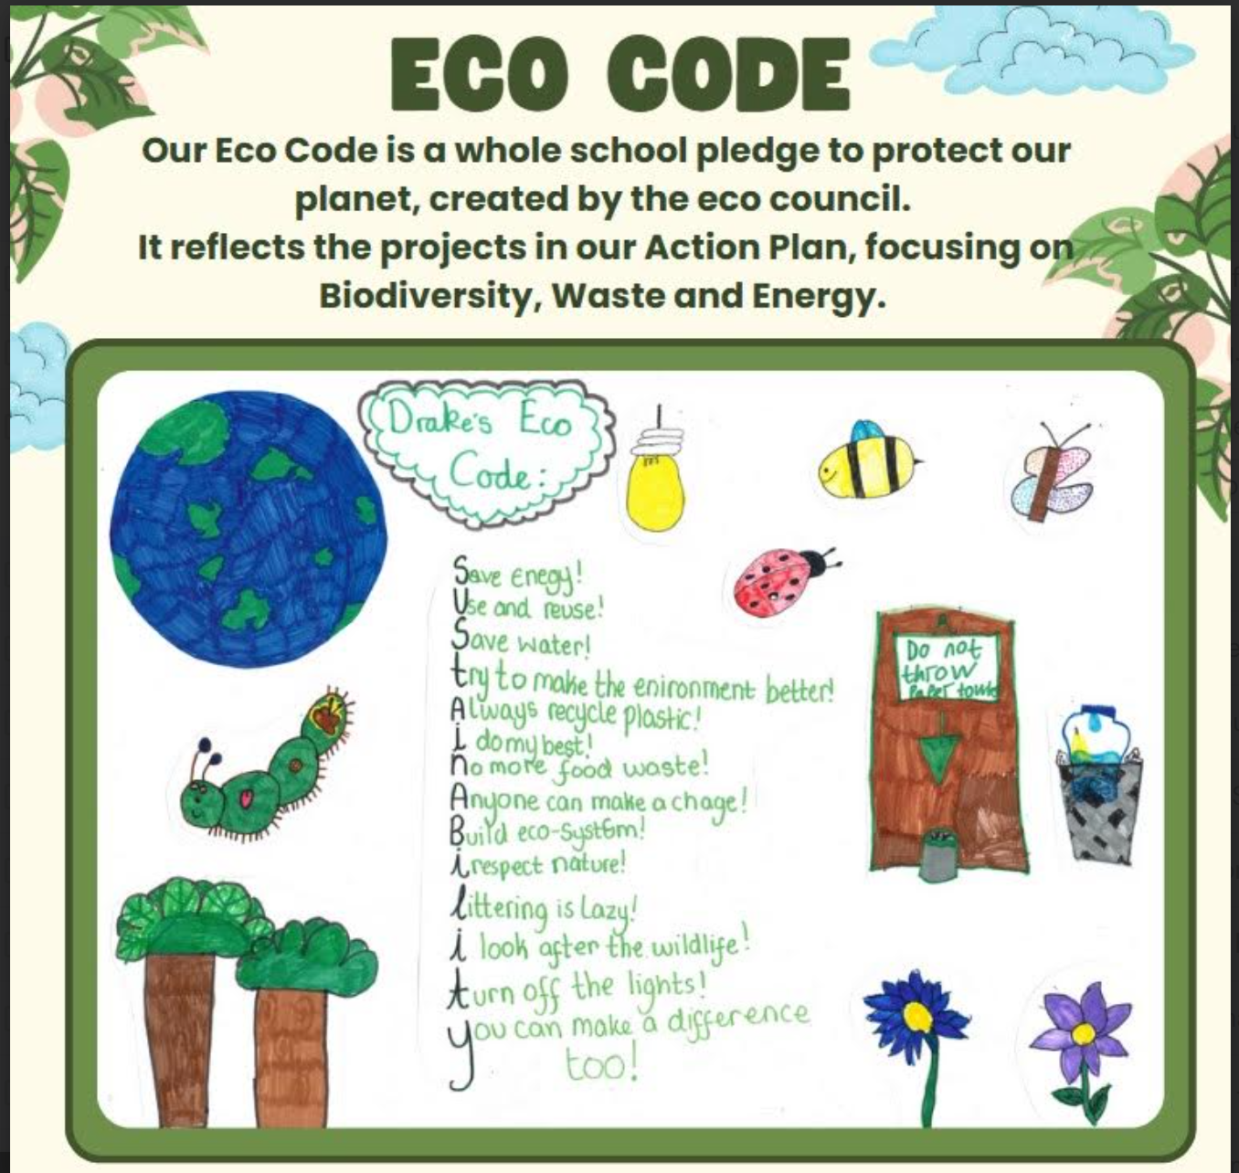
Culture: Organise a working group to focus on CCE, with staff, pupil and governor representation. |  | DW  SF  KF  Holden Cook (sustainability governor) | Start date: Autumn 2024  Review Date: Ongoing | Useful links: | Staff time | Sustainability leads across federation working together- half termly meetings.  Sustainability is an agenda termly in governor meetings
Culture: Include sustainability as a regular agenda point in staff briefing |  | DW  SF  SLT | Start date: Oct 2024  Review date: Ongoing | Useful links: | Staff time | Sustainability has a regular slot each week in staff briefings.
Community: Give a permanent space for sustainability in the weekly school newsletters |  | SF  DW  SLT | Start date: Autumn 2024  Review Date: Ongoing | Useful links: https://www.drake.norfolk.sch.uk/stream/newsletters/full/1/-// | Staff time | Newsletters-  Autumn term 2024:  27.9.24- Wetland update  11.10.24- Gardening Club update  19.10.24- Recycling Week  8.11.24- Cut Your Carbon  15.11.24- CAPE Project overview  22.11.24- Climate Change Assembly  29.11.24- Biodiversity mapping  6.12.24- Monitoring electricity  13.12.24- NENP Hidden Nature Challenge  20.12.24- Tips for a sustainable Christmas  Spring term 2025:  17.1.25- Eco environmental review  24.1.25 Big Garden Birdwatch
Curriculum: Create a climate section in the library.  Create a staff CPD climate change library. |  | SF  DW  KF (Librarian) | Start date: Summer 2025  Review Date: Summer 2025 | Useful links: | Staff time  Climate change books funded by TEFT grant £5000 grant | TEFT grant awarded in Jan 2024
Curriculum: British Science Week 2025 theme = Change and adapt, w/b 10th March 2025  Our 2025 BSW will focus on climate change. |  | DW  SF  KF  Class teachers | Start date: Mar 2025  Review Date: | Useful links: https://www.britishscienceweek.org/the-theme-for-2025-is-change-and-adapt/ | Staff time | Norwich Science Festival Play to KS2 on 13.2.25 (Food Scientists to the rescue- exploring the links between food and our planet, our diet and climate change).  Science, Art, Writing (SAW) Day in Y5 on 13th Mar and 14th Mar- workshops run by STEM Ambassadors.  SF, DW and KF planned climate change activities for BSW on 21.1.25
 |  |  | Start date:  Review Date | Useful links:

Decarbonisation

Our Vision- How can we education setting reduce emissions and support students to be part of the transition to net zero?
- The UK is committed to reaching net zero by 2050. School is aiming to reduce carbon emissions- this is needed to avoid global temperatures rising beyond 1.5°C (global temperatures have risen by 1.1°C currently).
- Assess schools current carbon emissions. We will collect data and calculate Drake’s carbon footprint, so we have a carbon baseline.
- We will take actions to reduce carbon emissions and become more energy efficient. We will decide what to prioritise - what actions will have the greatest reduction in our carbon footprint?
- Set targets (short term, medium term and long term) to reduce carbon emissions.
- We will monitor our carbon emissions and track the improvements.
Prompt Questions:
- What are the total carbon emissions of the education settings operations?
- How efficient are the education settings buildings?
- How could the education setting retrofit their estate and improve energy efficiency?
- Could the education setting reduce their waste and encourage reuse and recycling?
- Does the education setting adopt sustainable procurement practices?
- Does the education setting have food bins or compost their food waste on site?
- Does the education setting have a travel plan which encourages staff and students to take zero and lower emission forms of travel to and from the setting?
Action  (highlighted = completed) | Link to  Improvement Plan | Responsibility and Key Stakeholders | Timescale | Information and/or resources required | Cost | Progress  (Update at regular review points)
Energy: Install solar panels to generate renewable energy.  Collect data on energy usage from electricity bills. Analyse your school’s out-of-school hours energy usage. carry out a spot check to see if electrical items are left on after school. Look particularly at the charging banks, printers, etc. Where possible, use 7-day timer switches.  Energy champions: engage students in energy monitoring: Eco Council to read electricity metres / solar panels. | Personal Development:  The school consistently promotes the extensive personal development of pupils through our focus on becoming a sustainable school. We go beyond the expected, so that pupils have access to a wide, rich set of experiences as we work towards a more equitable future. Opportunities for pupils to develop their talents and interests in our pupil-led sustainability work are of exceptional quality.  Recognise everyone’s role in the future of the world and its climate. | SLT  Site staff  NO-C  Eco Council  DW  SF | Start date: Aug 2024  Review Date: Spring 2025 | Useful links: https://energysparks.uk/activity_categories/2 | Staff time  Solar panel cost | Additional solar panels installed in Aug 2024 on KS2 roof  Energy monitoring: 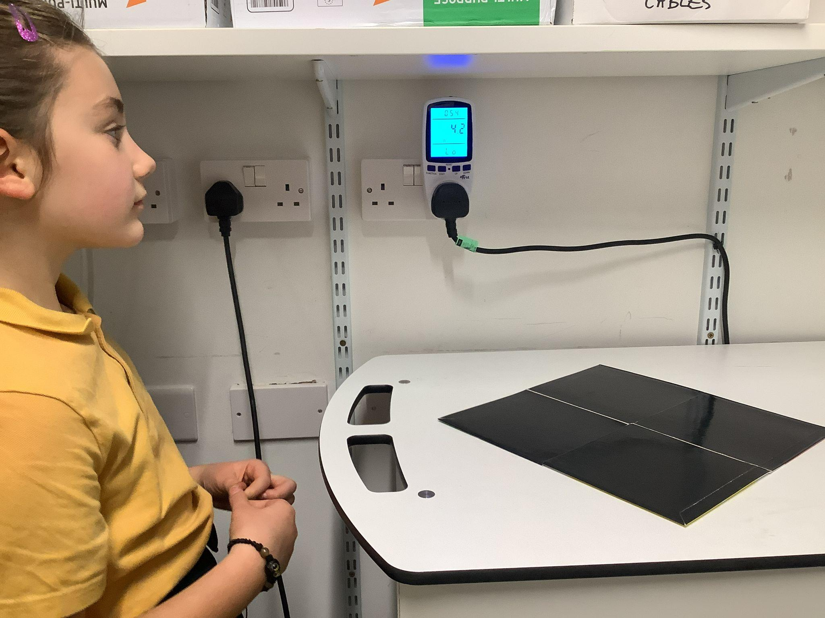  Timers on iPad and Chromebook charging banks:  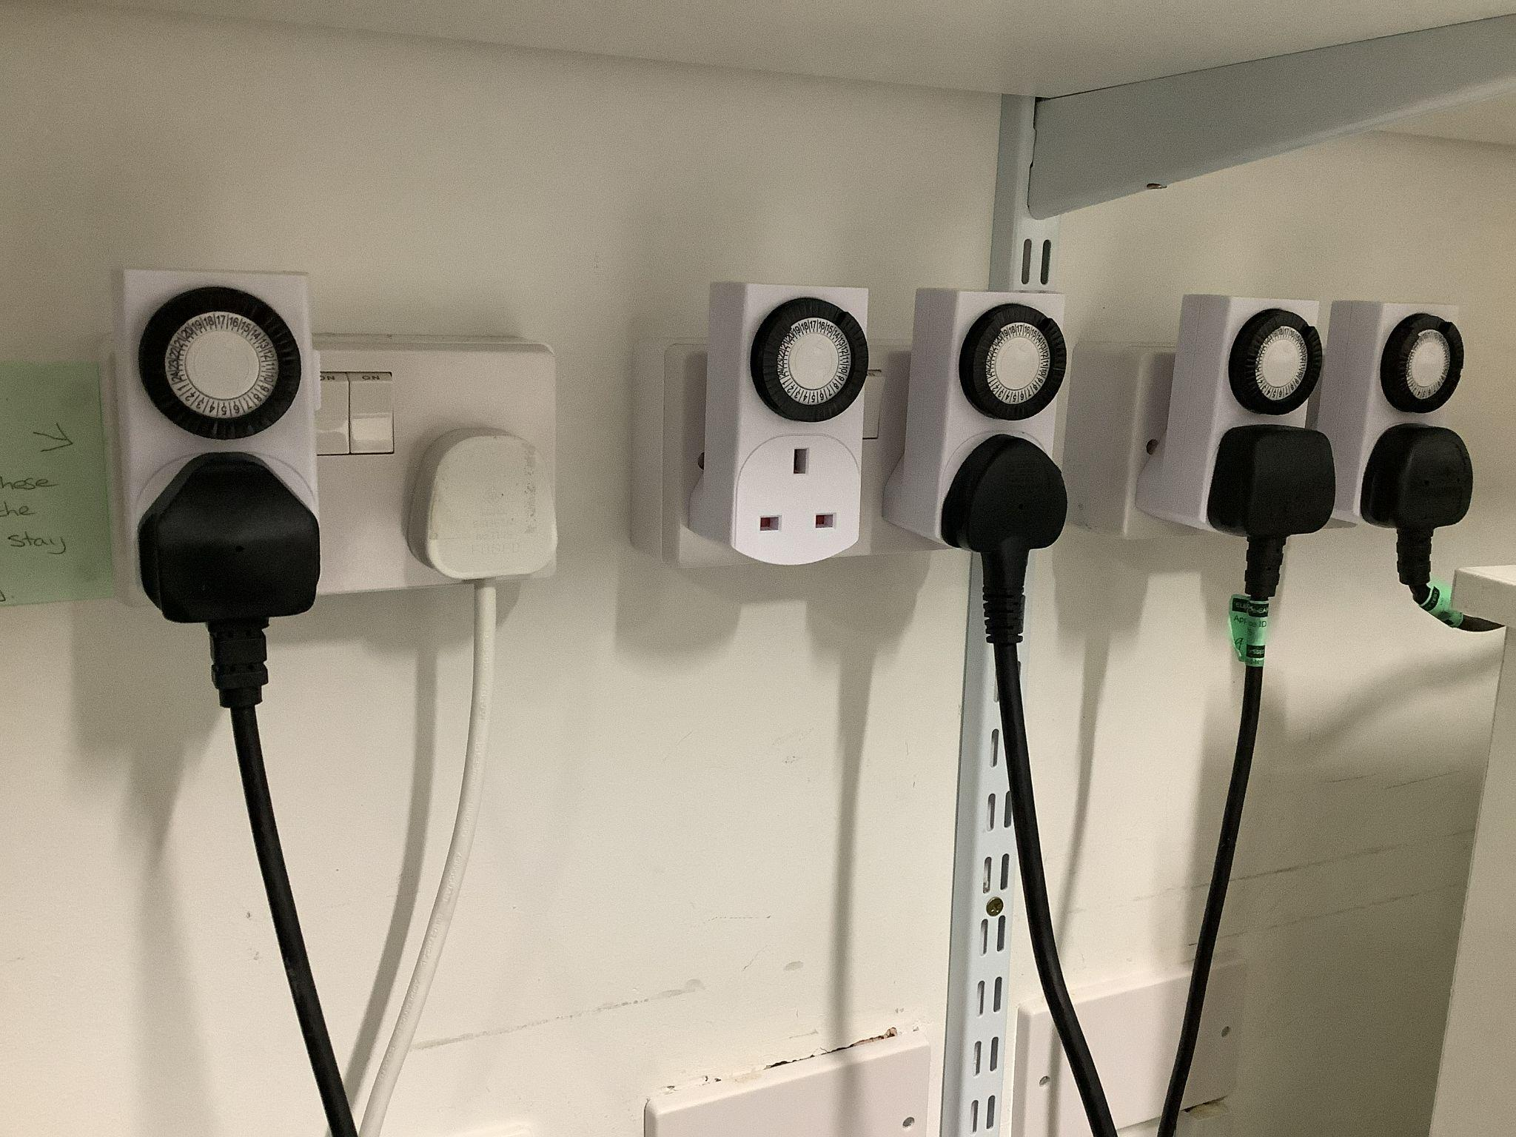
Energy: Install EVC points and electric minibuses. |  | SLT  Site staff | Start date: Sept 2024  Review Date: Spring 2025 | Useful links: | EVC cost  Electric minibuses cost  Training for staff to drive minibuses | EVC points installed in Sept 2024  Electric buses delivered on 16/01/2025  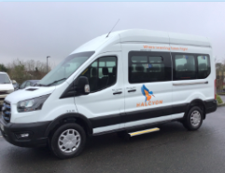  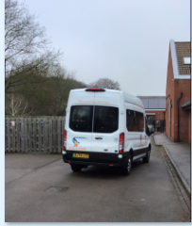
Energy: Install energy saving LED light bulbs - motion sensor |  | SLT  Site staff | Start date: Jul 2024  Review Date: Oct 2024 | Useful links: | Staff time | LED light bulbs installed in 2024
Energy: Meet with Let’s Go Zero Climate Action Advisor (Luciana Almeida) to discuss priorities and next steps for the school site, to reduce carbon emissions.  Sustainability audit, to find out our baseline. Conduct a carbon audit to identify the biggest impact areas in the school.  Work out the carbon emissions of the school (Count your carbon). |  | SF  DW  SLT | Start date: 4.10.24  Review Date: Feb 2025 | Useful links: https://letsgozero.org/  https://www.countyourcarbon.org/ | Staff time | Teams meeting with Climate Action Advisor on 4.10.24 (SF and DW)  Sustainability Audit @ Drake 24.10.24, with Luciana Almeida (climate advisor)  Carbon Footprint from Let’s Go Zero in Nov 2024  Sustainability report presentation 7.11.24  Climate Action Plan from Let’s Go Zero 12.11.24  Carbon Footprint from Green Schools Programme in Jan 2025  Climate action plan check-in with Luciana on 27.2.25
Energy: Meet with site staff and discuss current energy usage / utility bills.  Discuss thermostat- at what temperature does the heating turn on? Can we turn down the thermostat by 1oC? 2. Experiment with changing timings of your heating. |  | Site staff  DW  SF  NO-C  SC | Start date: Summer 2025  Review Date: Autumn 2025 | Useful links: | Staff time | SC - Holiday mode.  Outside lights have been reprogrammed
Waste: Review our recycling - paper / card  Ensure all recycling bins are clearly labelled and have clear expectations about what can / cannot be recycled, to support with behaviour change. | Personal Development: There is strong pupil take-up of the opportunities to be involved in waste reduction projects provided by our school. The most disadvantaged pupils consistently benefit from this excellent work for example by working in our Eco Team coordinating our waste projects. | Site staff  SF  DW  All staff | Start date: Spring 2025  Review Date: Summer 2025 | Useful links: https://www.youngclimatewarriors.org/inspirational-resources  https://schools.recyclenow.com/resources/ | Staff time | 17/12/24 - Poster taken round to every class to display around recycling.  Poster also placed in the staffroom by recycling bin and email sent to all staff.  Recycle bins audit by Eco Council on 17.1.25  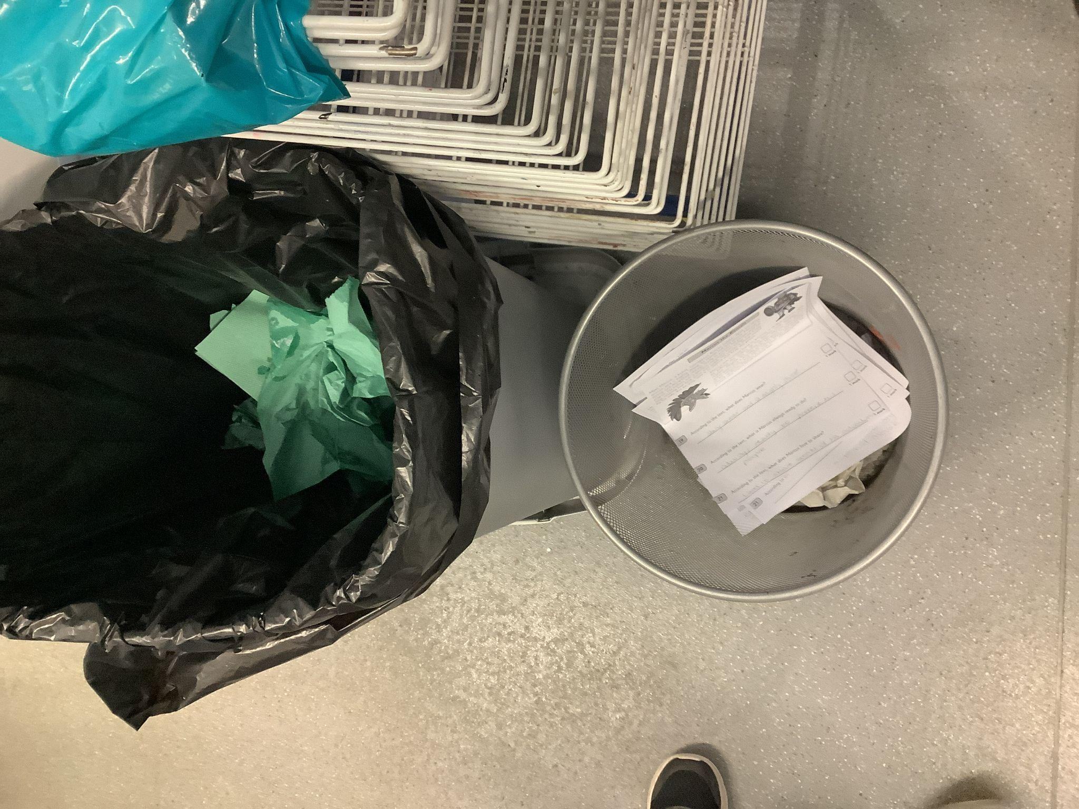
Waste: Review the use of single use plastics (e.g. in lunches)  Sign up to plastic free schools - Achieve Plastic Free Schools accreditation. Successfully use the resources to educate children on reducing plastic waste. Commit to eliminating 3 types of single use plastic and get sent a plaque. |  | SF  DW | Start date: Sept 2025  Review Date: Autumn 2026  Plastic Free to run in 2025/26 | Useful links: https://plasticfreeschools.org.uk/ | Staff time | SF - Discovered Tesco superstore, Thetford recycles soft plastic - bread bags, salad bags, sweet wrappers, crisp packets etc.  Going to organise for us to recycle these things at school with a 1 day week trip to take to Tesco.
Waste: Review food bins / food waste / compost bins.  KS1 compost food waste from morning snack. |  | Site staff  All staff  Children | Start date: Spring 2025  Review Date: Summer 2025 | Useful links: | Staff time | 17/12/24 - email to all staff re food caddies we had - snack waste to go in compost bins.
Communication: Regular updates to the sustainability page on the website.  Regular updates on Halcyon Instagram and Halcyon website. |  | DW  SF | Start date: Autumn 2024  Review Date: Ongoing | Useful links: https://www.drake.norfolk.sch.uk/sustainability/  https://halcyonfederation.org/ | Staff time | Updated sustainability page on Drake website.
Transport: Travel plan - undertake a travel survey and consult staff on commuting.  Participate in the three annual Active Travel Weeks. Aim for these events to trigger a permanent shift to sustainable travel from students who live locally enough to do so.  - Sustrans Big Walk and wheel = April 2025  - Living Streets Walk to School Week = May 2025  - Cycle to school week = September 2025  Encourage families to walk / scoot / cycle / car share where possible / walk the last bit of the journey to school  Review bike / scooter storage at school.  Promote lower carbon transportation options.  Register for ModeShift STARS to create and implement your school travel. | Personal Development: We develop pupils’ character through developing their understanding of how to keep physically healthy, eat healthily and maintain an active lifestyle, including giving ample opportunities to learn about sustainable lifestyle choices. | SC  SF  DW | Start date: Oct 2024  Review Date: Spring term 2025 | Useful links: https://www.livingstreets.org.uk/walk-to-school/primary-schools/walk-to-school-week/  https://bigwalkandwheel.org.uk/  https://www.bikeability.org.uk/cycletoschoolweek/  https://modeshiftstars.org/ | Staff time | Travel survey (staff and pupils) undertaken in Oct 2024  Travel plan on website sustainability page
Procurement: Review the companies we purchase from. Are we re-using everything we can?  Create a sustainable procurement policy to ensure that any purchase minimise environmental and social harm and that all electrical items are efficient.  Switch to recycled or sustainability sourced paper.  Consider using School Resources Exchange when purchasing new resources. | Spiritual, moral, social and cultural development: Our school sustainability work engenders acceptance of and engagement with the fundamental British values of individual liberty and mutual respect. Activities such as our Uniform recycling work ensure that children know how to value and respect our world and each other. | DW  SF  NO-C | Start date: Spring 2025  Review Date: Autumn 2025 | Useful links: https://www.eco-schools.org.uk/wp-content/uploads/2016/12/Green-Procurement.pdf  https://www.school-resources-exchange.co.uk/ | Staff time
Food: Get a free menu consultation from Pro-Veg ProVeg UK  Keep involving the students in weighing the canteen food waste.  Run an assembly with students on sustainability and food | Personal Development: The way our school goes about developing pupils’ character through their Climate Conscious choices is exemplary and is worthy of being shared with others. We work with schools across our region sharing our strategies and successes to benefit our wider schools family. | SF  DW  Eco Council  SNAC Council | Start date: Summer 2025  Review Date: Aut 2025 | Useful links: https://proveg.org/uk/about-us/

